7.1.1 - Measures initiated by the Institution for the promotion of gender equity during the year
- Safety and security (Internal Complaints Committee Policy Document)
- Medical Room
- Common Rooms
- Any other relevant information (Sanitary Vending Machine)

Separate washroom for Girls and Female staff
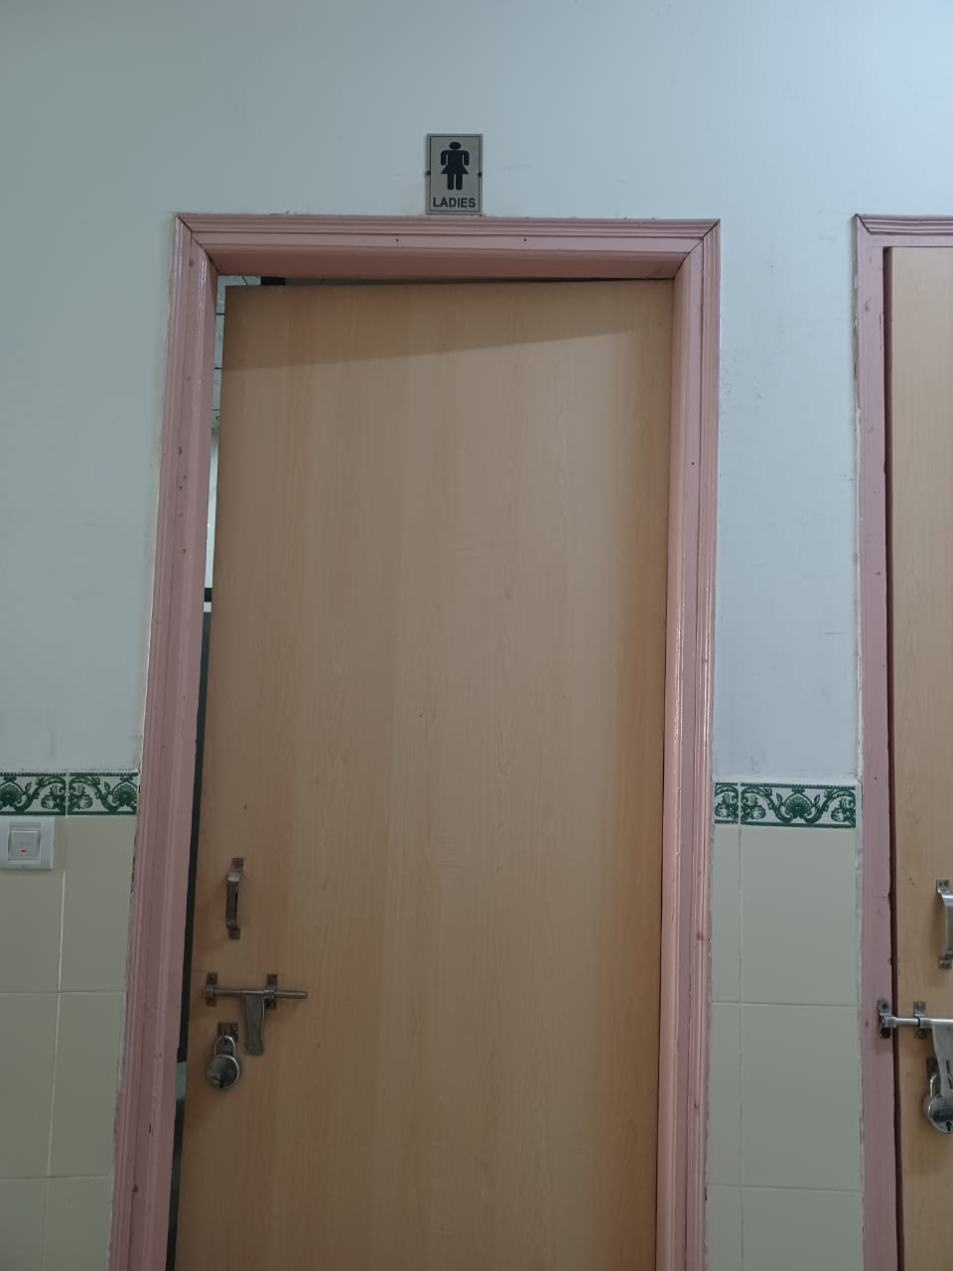

Sanitary Vending Machine
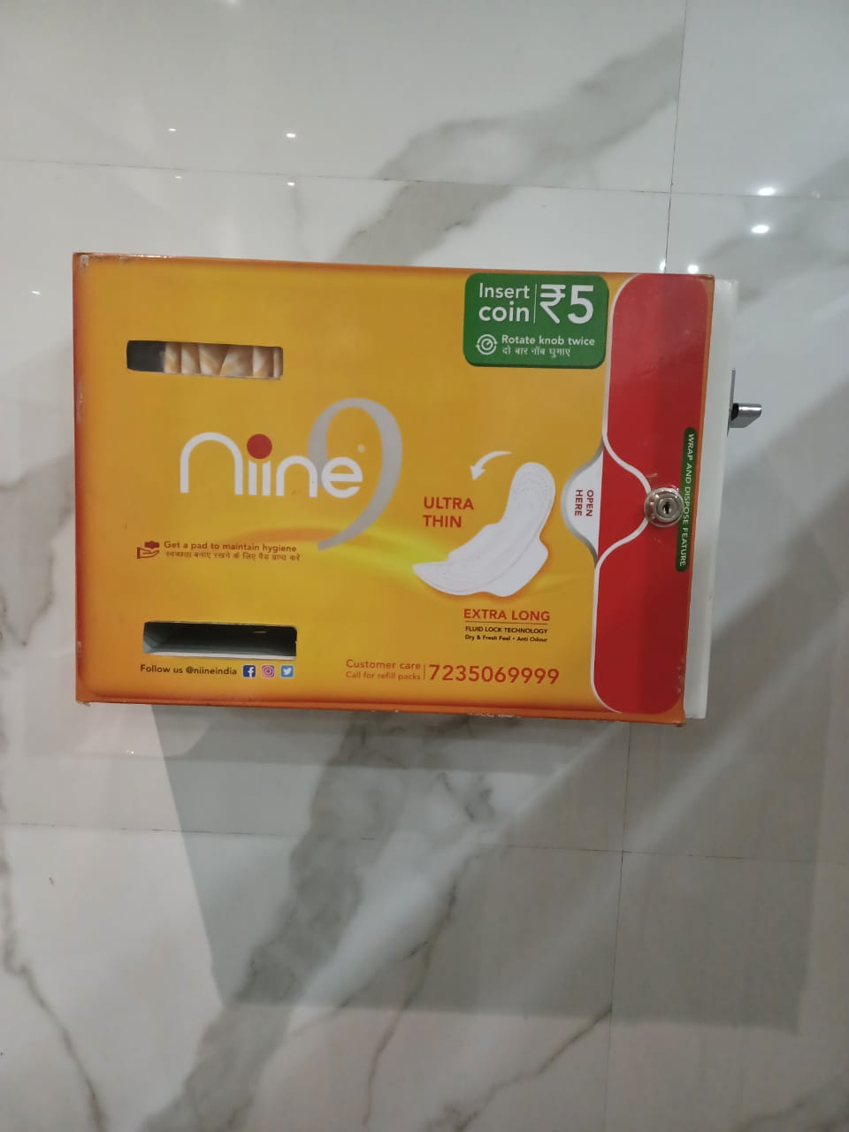
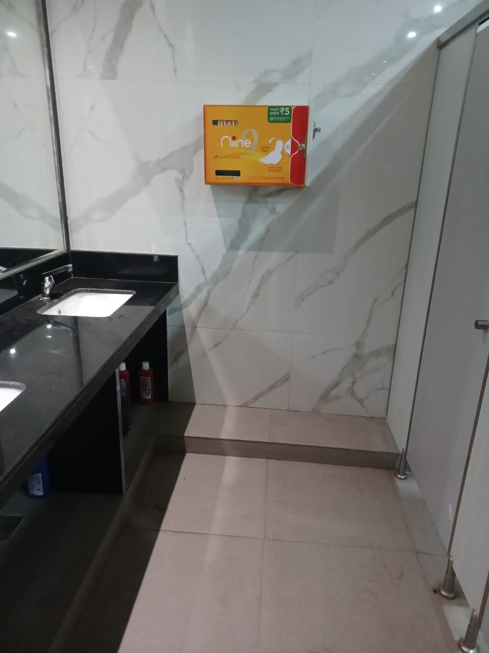

Medical Room
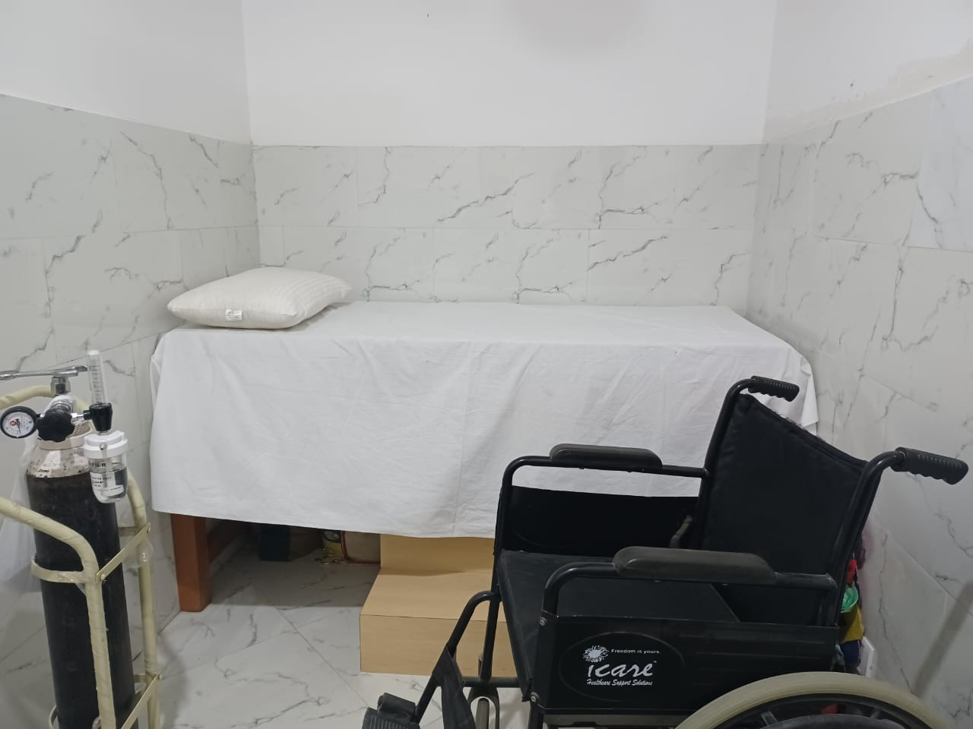
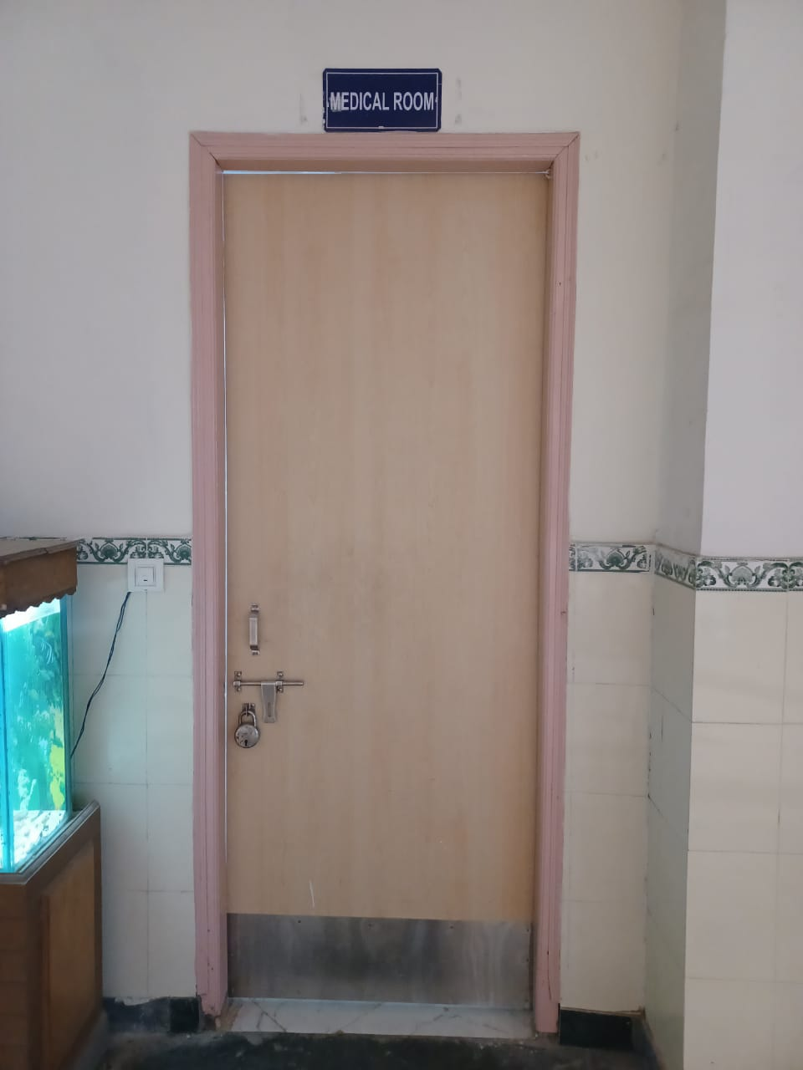

Girls Common Room
